Galala University

College of Computer Science and Engineering

CSE 014 Structured Programming

Project Title:

Health Care App

Project Team Members:

Abd Elrahman Mohamed Ali Hassan ID: 22210096

Mohamed Mahmoud Abdel ghany Mohamed ID: 222101431

Christian Hany Roshdy ID:222101191

Osama Adel Fawzy ID: 222100211

1. Project Code Listing:

/*The program is designed to ask the user about his/her current weight

and some body dimensions to calculate the average body fat

percentage. To help the user know his health status and whether his

health is changing to the better or getting worse. Also helping the user

to know the sugar levels of his body and blood pressure to be alerted of

his health.*/

#include <iostream>

#include <fstream>

#include <string>

using namespace std;

#define name_file "data_siup_loin/"

void sign_up();

void log_in();

void log_out();

void menu() ;

void body_fat();

void muscle_percentage();

void water_percentage();

//main function

int main()

{

system("color 02");

system("cls");

//login_and_sing up code

char n ;

cout << "\n\n\n\n\n\n\n\n\n\n\n\n\n\n\n\n\n\n\t\t\t\t\t@@@@@@@@@@@@@@@@@@@@@@@@@@@@@@@@@@@@@@@@@@@@@@@@@@@@@@@@@@@@@@@@@@@@@@@@@@@@@@@@@@@@@@@@@@@@@\n";

cout << "\t\t\t\t\t@@ _______________________________________________________________________________________ @@\n";

cout << "\t\t\t\t\t@@| |@@\n";

cout << "\t\t\t\t\t@@| |@@\n";

cout << "\t\t\t\t\t@@| |@@\n";

cout << "\t\t\t\t\t@@| |@@\n";

cout << "\t\t\t\t\t@@| |@@\n";

cout << "\t\t\t\t\t@@| |@@\n";

cout << "\t\t\t\t\t@@| WELCOME TO |@@\n";

cout << "\t\t\t\t\t@@| |@@\n";

cout << "\t\t\t\t\t@@| HEALTH CARE APPLECATION |@@\n";

cout << "\t\t\t\t\t@@| |@@\n";

cout << "\t\t\t\t\t@@| |@@\n";

cout << "\t\t\t\t\t@@| |@@\n";

cout << "\t\t\t\t\t@@| |@@\n";

cout << "\t\t\t\t\t@@| |@@\n";

cout << "\t\t\t\t\t@@| |@@\n";

cout << "\t\t\t\t\t@@|_______________________________________________________________________________________|@@\n";

cout << "\t\t\t\t\t@@@@@@@@@@@@@@@@@@@@@@@@@@@@@@@@@@@@@@@@@@@@@@@@@@@@@@@@@@@@@@@@@@@@@@@@@@@@@@@@@@@@@@@@@@@@@\n\n\n\n\t\t\t\t\t";

system("pause");

system("cls");

cout << "\n\t\t\t\t\t\t\tpress 1 to SignUp";

cout << "\n\t\t\t\t\t\t\tpress 2 to LogIn\n";

cin >> n;

if (n == '1')

sign_up();

else if (n == '2')

log_in();

else

{

cout << "\t\t\t\t\t\t\tYou didn't choose 1 or 2....\n";

cout << "\t\t\t\t\t\t\t\tTry again...\n";

system("pause");

//redirect to main function

main();

}

//delete the screen contents

system("cls");

//--------------------------------------------

//menu function

menu();

//--------------------------------------------

return 0;

}

//sign up function

void sign_up()

{

cout << "\n\t\t\t\t------------------------------signup-------------------------------\n\n";

string mail, username, password, age , weight , gander;

cout << "\t\t\t\t\t\t\tEnter your username: ";

cin >> username;

cout << "\t\t\t\t\t\t\tEnter your age: ";

cin >> mail;

cout << "\t\t\t\t\t\t\tEnter your gander: ";

cin >> gander;

cout << "\t\t\t\t\t\t\tEnter your mail: ";

cin >> mail;

cout << "\t\t\t\t\t\t\tEnter your password: ";

cin >> password;

// open file data

ofstream ofile;

ofstream obfile;

string userfile = name_file + username + ".txt";

ofile.open(userfile);

ofile << username << endl << mail << endl << age << endl << gander << endl << password;

ofile.close();

obfile.close();

cout << "\n\t\t\t\t\t\t You are successfully registered:)\n";

cout << "\t\t\t\t\t\t ";

system("pause");

system("cls");

//redirect to log in function

log_in();

}

// log in function

void log_in()

{

cout << "\n\t\t\t\t------------------------------login--------------------------------\n\n";

string getpassword, getusername, password , username , getmail , getage , getgander;

cout << "\t\t\t\t\t\t\tEnter your username: ";

cin >> username;

cout << "\t\t\t\t\t\t\tEnter your password: ";

cin >> password;

//verify from files

ifstream getdatafile;

string userfile = name_file + username + ".txt";

getdatafile.open(userfile);

if (getdatafile.is_open())

{

getline(getdatafile, getusername);

getline(getdatafile, getmail);

getline(getdatafile, getage);

getline(getdatafile, getgander);

getline(getdatafile, getpassword);

if (username == getusername && password == getpassword) {

cout << "\n\t\t\t\t\t\t You are successfully logged in:)\n";

cout << "\t\t\t\t\t\t ";

system("pause");

getdatafile.close();

system("cls") ;

// redirect to menu function

menu();

}

else {

cout << "\n\t\t\t\t\t\t Wrong username or password!\n";

cout << "\t\t\t\t\t\t\t Please try Again.\n";

log_in();

}

cout << endl;

}

else

{

cout << "\n\t\t\t\t\t\t\t Username not found.\n";

cout << "\t\t\t\t\t\t\t please sign up.\n";

sign_up();

}

}

void menu()

{

char N ;

cout << "\n\t\t\t\t---------------------------main menu-------------------------------\n";

cout << "\t\t\t\t\t[1]measuring The Change of Body fat percentage\n";

cout << "\t\t\t\t\t[2]Water Percentage\n";

cout << "\t\t\t\t\t[3]Muscle percentage\n";

cout << "\t\t\t\t\t[4]Log Out\n";

cin >> N ;

if (N == '1')

{

body_fat() ;

}

else if (N == '2')

{

water_percentage();

}

else if (N == '3')

{

muscle_percentage();

}

else if (N == '4')

{

log_out();

}

else

{

cout << "\t\t\t\t\t\t\tYou didn't choose 1 or 2....\n";

cout << "\t\t\t\t\t\t\t\tTry again...\n";

system("pause");

main();

}

//delete the screen contents

system("cls");

//--------------------------------------------

//menu function

menu();

//------------------------------------- return 0;

}

void body_fat()

{

char G ;

double waist , hips , neck ,height , b_f_percentage , abdomen ;

cout << "\n\t\t\t\t\t\t\tChoose Your Gander\n";

cout << "\n\t\t\t\t\t\t\[1] Male\n";

cout << "\n\t\t\t\t\t\t\[2] Female\n";

cin >> G;

if (G == '1')

{

cout << "\n\t\t\t\t\t\t\tEnter your waist size \n";

cin >> waist ;

cout << "\n\t\t\t\t\t\t\tEnter your hips size \n";

cin >> hips ;

cout << "\n\t\t\t\t\t\t\tEnter your neck size \n";

cin >> neck ;

cout << "\n\t\t\t\t\t\t\tEnter your Height \n";

cin >> height ;

b_f_percentage = 163.205 * (waist + hips - neck) - 97.684 * (height) - 78.387 ;

cout << "\n\t\t\t\t\t\t\tYour Body Fat Percentage is:" << b_f_percentage << endl ;

system("pause");

}

else if (G == '2')

{

cout << "\n\t\t\t\t\t\t\tEnter your Abdomen size \n";

cin >> abdomen ;

cout << "\n\t\t\t\t\t\t\tEnter your neck size \n";

cin >> neck ;

cout << "\n\t\t\t\t\t\t\tEnter your Height \n";

cin >> height ;

b_f_percentage = 86.010 * (abdomen - neck) - 70.041 * (height) + 36.76 ;

cout << "\n\t\t\t\t\t\t\tYour Body Fat Percentage is:" << b_f_percentage << endl ;

system("pause");

}

else

{

cout << "\t\t\t\t\t\t\tYou didn't choose 1 or 2....\n";

cout << "\t\t\t\t\t\t\t\tTry again...\n";

system("pause");

system("cls") ;

body_fat() ;

}

//delete the screen contents

system("cls");

}

void water_percentage()

{

char W ;

double Age , Weight ,Height , w_p ;

cout << "\n\t\t\t\t\t\t\tChoose Your Gander\n";

cout << "\n\t\t\t\t\t\t\[1] Male\n";

cout << "\n\t\t\t\t\t\t\[2] Female\n";

cin >> W;

if (W == '1')

{

cout << "\n\t\t\t\t\t\t\tEnter your age \n";

cin >> Age ;

cout << "\n\t\t\t\t\t\t\tEnter your weight \n";

cin >> Weight ;

cout << "\n\t\t\t\t\t\t\tEnter your Height \n";

cin >> Height ;

w_p =2.447 - (0.09145 * Age) + (0.1074 * Height) + (0.3362 * Weight) ;

cout << "\n\t\t\t\t\t\t\tYour Body water Percentage is:" << w_p << endl ;

system("pause");

}

else if (W == '2')

{

cout << "\n\t\t\t\t\t\t\tEnter your age \n";

cin >> Age ;

cout << "\n\t\t\t\t\t\t\tEnter your weight \n";

cin >> Weight ;

cout << "\n\t\t\t\t\t\t\tEnter your Height \n";

cin >> Height ;

w_p = 2.097 + (0.1069 * Height) + (0.2466 * Weight) ;

cout << "\n\t\t\t\t\t\t\tYour Body Water Percentage is:" << w_p << endl ;

system("pause");

}

else

{

cout << "\t\t\t\t\t\t\tYou didn't choose 1 or 2....\n";

cout << "\t\t\t\t\t\t\t\tTry again...\n";

system("pause");

system("cls") ;

water_percentage() ;

}

//delete the screen contents

system("cls");

}

void muscle_percentage()

{

char X ;

double B_F_P , m_p ;

cout << "\n\t\t\t\t\t\t\tChoose Your Gander\n";

cout << "\n\t\t\t\t\t\t\[1] Male\n";

cout << "\n\t\t\t\t\t\t\[2] Female\n";

cin >> X;

if (X == '1')

{

cout << "\n\t\t\t\t\t\t\tEnter your Body Fat Percentage \n";

cin >> B_F_P ;

m_p = (100 - B_F_P) ;

cout << "\n\t\t\t\t\t\t\t your muscle Percentage is:" << m_p << endl ;

system("pause");

}

else if (X == '2')

{

cout << "\n\t\t\t\t\t\t\tEnter your Body Fat Percentage \n";

cin >> B_F_P ;

m_p = 100 - B_F_P ;

cout << "\n\t\t\t\t\t\t\t your Muscle Percentage is:" << m_p << endl ;

system("pause");

}

else

{

cout << "\t\t\t\t\t\t\tYou didn't choose 1 or 2....\n";

cout << "\t\t\t\t\t\t\t\tTry again...\n";

system("pause");

system("cls") ;

muscle_percentage() ;

}

//delete the screen contents

system("cls");

}

void log_out()

{

main();

}

II-Testing

Welcome screen :

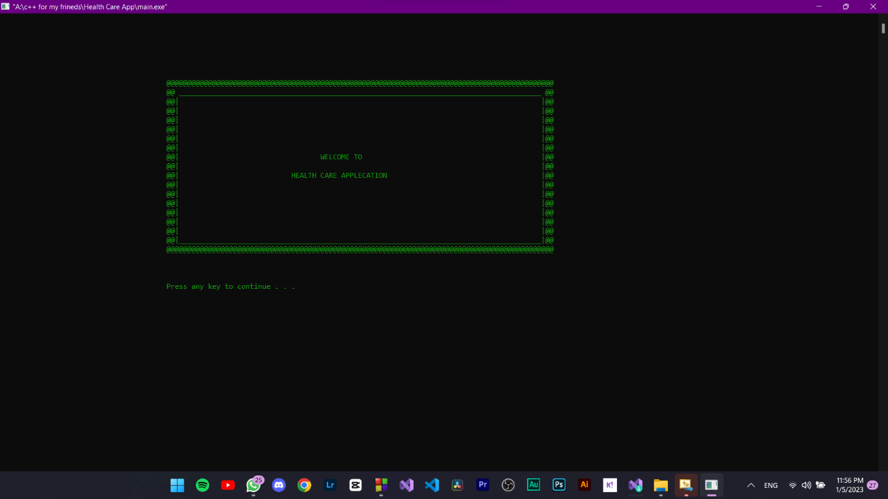

Sign up :

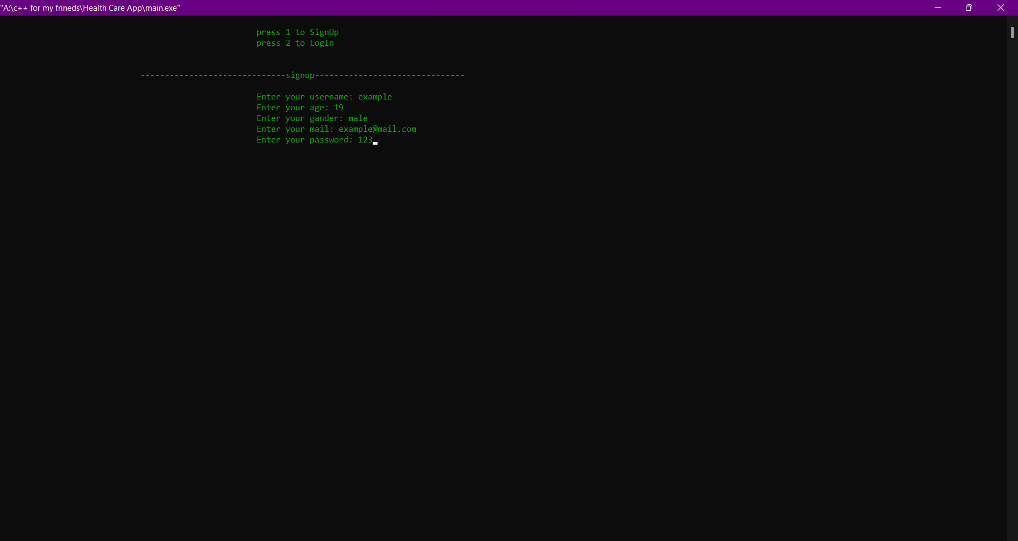

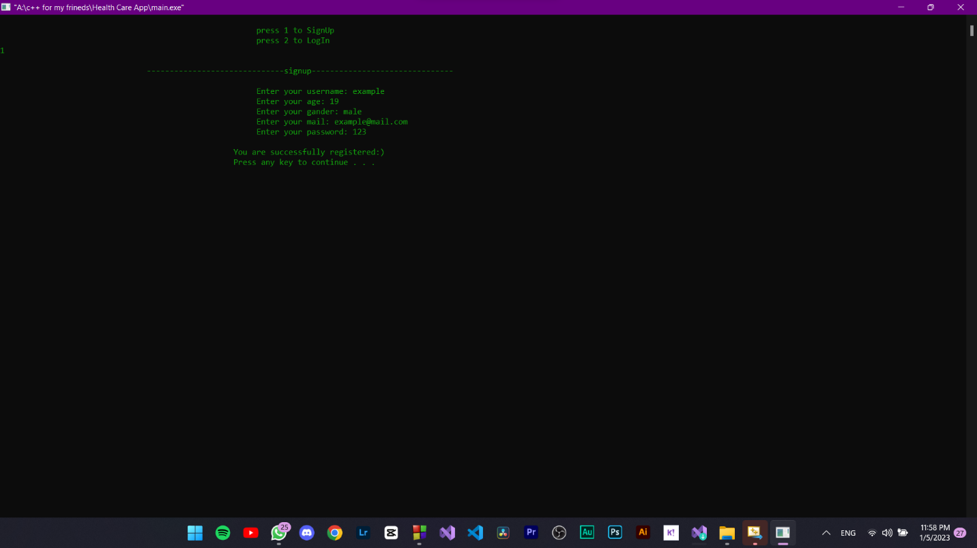

Sign in :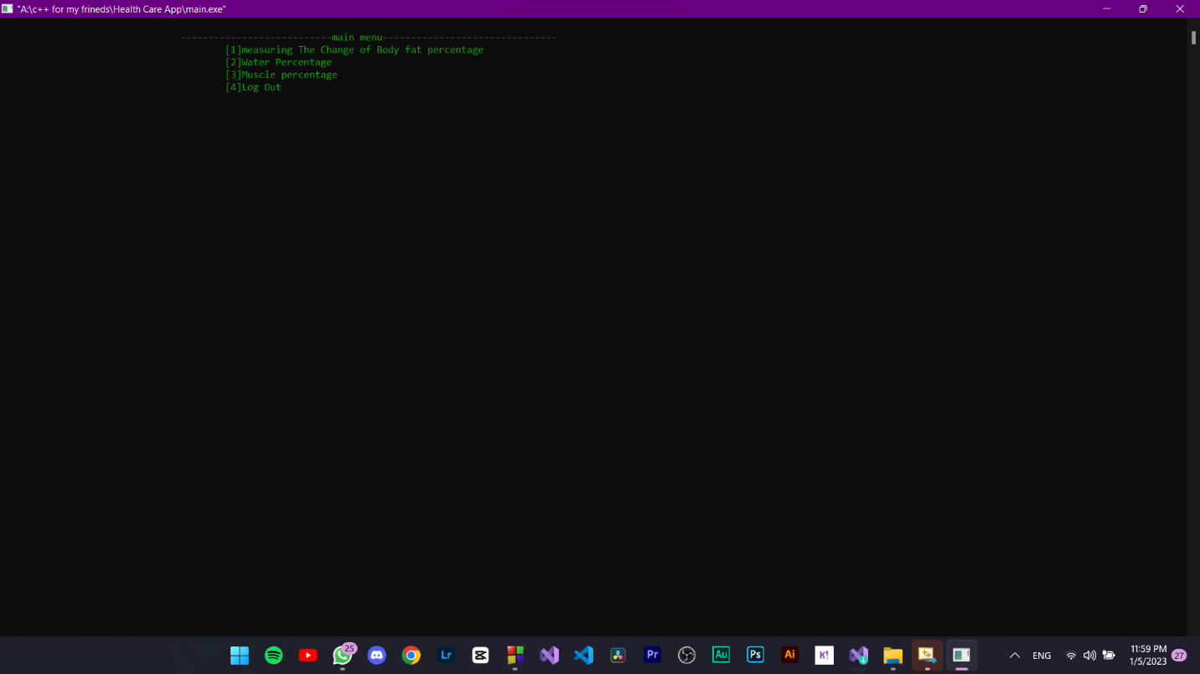

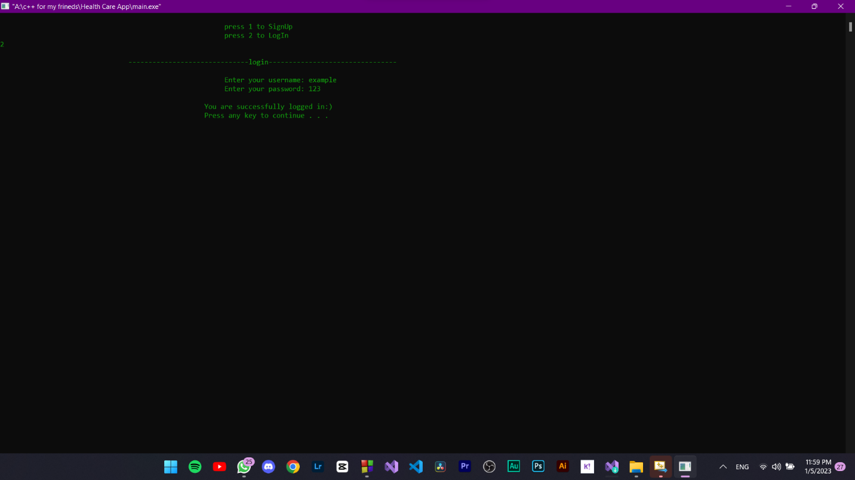

Menu screen :